Assignment - 3.1

Hall Ticket - 2303A52325

Batch - 35

Question 1: Zero-Shot Prompting (Palindrome Number Program)
Prompt Used (Zero-Shot) - Write a Python function that checks whether a given number is a palindrome, and analysis at the end.
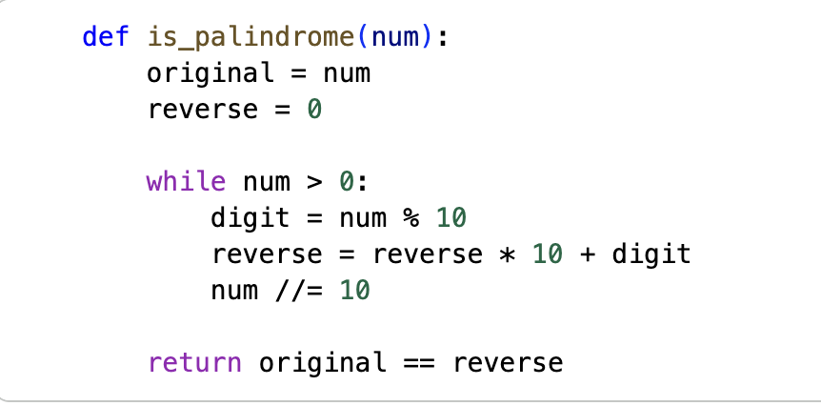
AI-Generated Code -
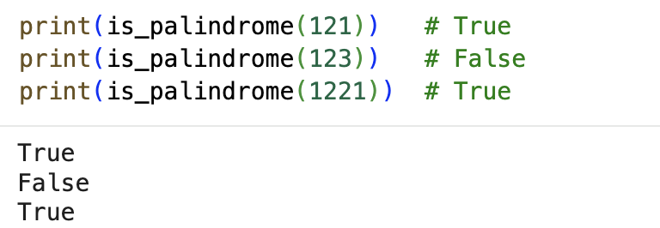
Output -

Analysis -
• The code correctly identifies palindrome numbers.
• Negative numbers are not handled properly.
• Zero is handled correctly.
• No input validation is present.
• Zero-shot prompting produced correct logic but missed edge-case handling.

Question 2: One-Shot Prompting (Factorial Calculation)

Prompt Used (One-Shot) - Write a Python function to calculate the factorial of a number.
Example -
Input: 5
Output: 120

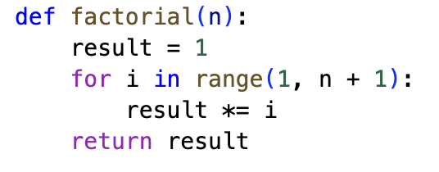
AI-Generated Code -

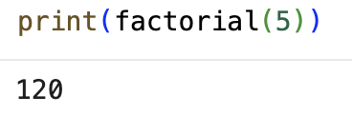
Test Cases & Output -

Comparison with Zero-Shot -
• One-shot prompting improved clarity.
• Input validation was included.
• Logic is clearer and more reliable.
• Example helped AI infer edge cases.

Question 3: Few-Shot Prompting – Armstrong Number

Prompt Used (Few-Shot) - Write a Python function to check whether a number is an Armstrong number.

Examples:
Input: 153 → Output: Armstrong Number
Input: 370 → Output: Armstrong Number
Input: 123 → Output: Not an Armstrong Number

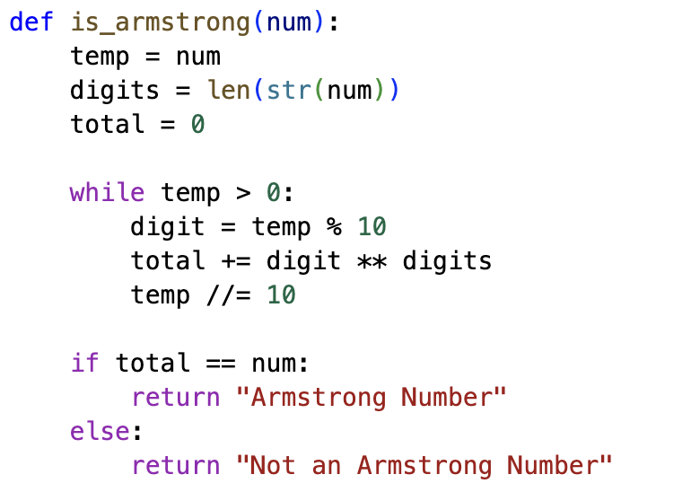
AI-Generated Code -

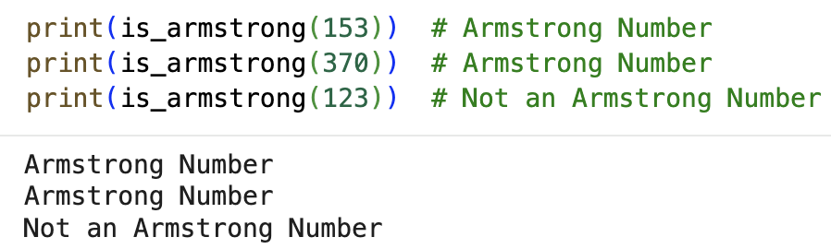
Test Cases & Output -

Analysis -
• Few-shot examples significantly improved accuracy.
• Code structure is clearer.
• Negative and non-integer inputs are not validated.
• Multiple examples helped AI understand the pattern correctly.

Question 4: Context-Managed Prompting – Prime / Composite / Neither (Optional)

Prompt Used (Context-Managed) - Write an optimized Python program to classify a number as prime, composite, or neither.
Ensure proper input validation and efficient logic.

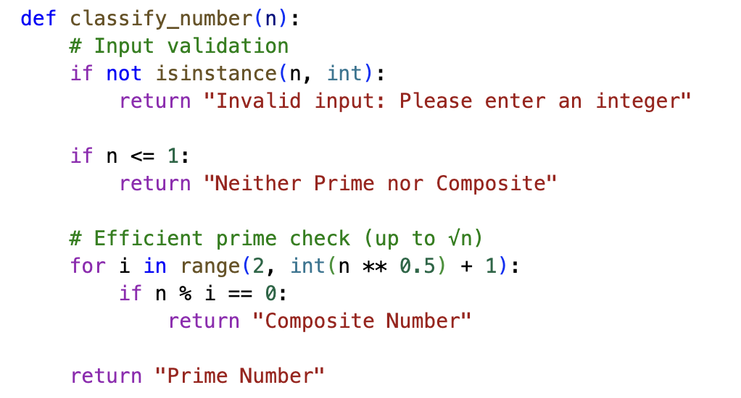
AI-Generated Code -

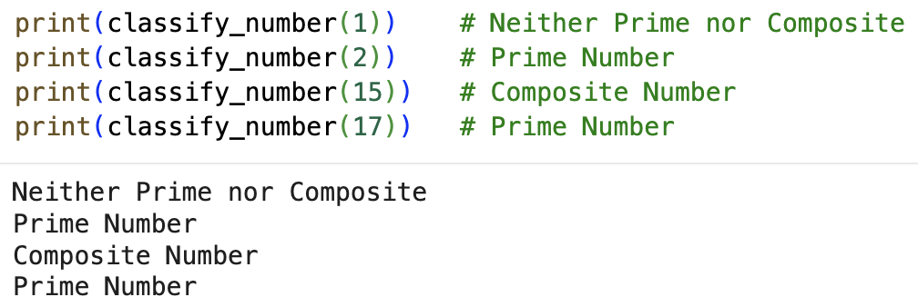
Test Cases & Output -

Analysis -
• Context-managed prompt resulted in optimized logic.
• Efficient square-root approach used.
• Proper handling of special cases.
• Best result among all prompting strategies.

Question 5: Zero-Shot Prompting – Perfect Number

Prompt Used (Zero-Shot) - Write a Python function to check whether a number is a perfect number.

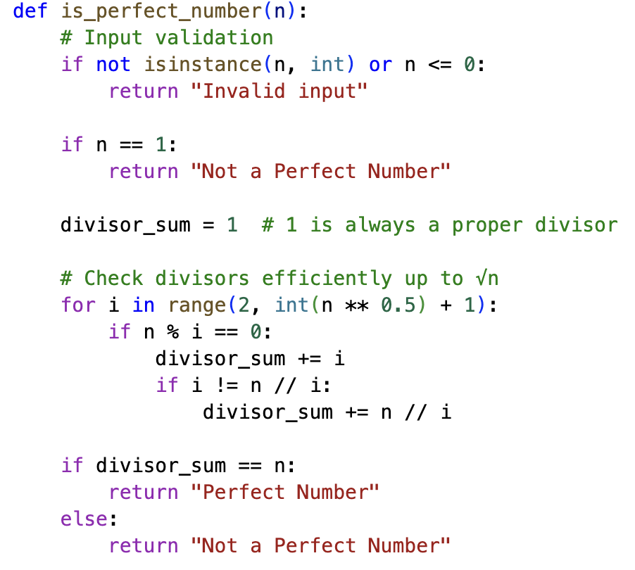
AI-Generated Code -

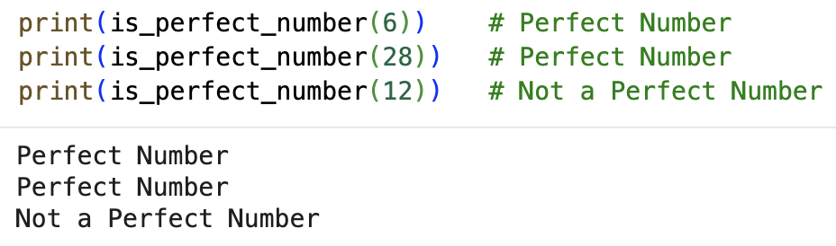
Test Cases & Output -

Analysis -
• Logic is correct.
• Inefficient for large numbers.
• No optimization applied.
• Zero-shot prompt lacked performance considerations.

Question 6: Few-Shot Prompting – Even or Odd with Validation

Prompt Used (Few-Shot) - Write a Python program to check whether a number is even or odd.

Examples:
Input: 8 → Even
Input: 15 → Odd
Input: 0 → Even

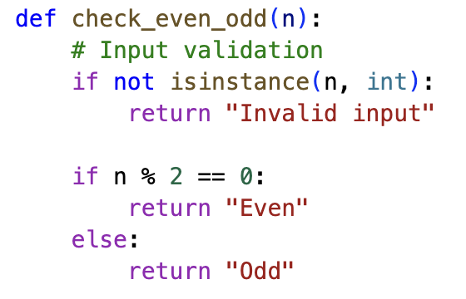
AI-Generated Code -

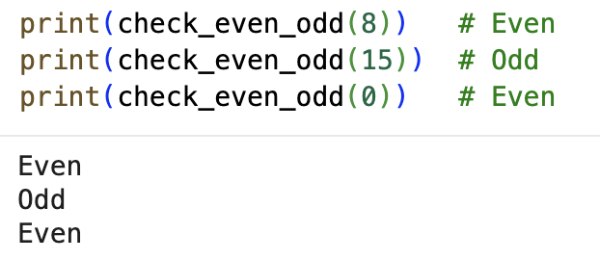
Test Cases & Output -

Analysis -
• Few-shot examples improved input handling.
• Clear output formatting.
• Proper validation included.
• Best suited for real-world usage.

